Highrise Training & Reference Information (v.4)

THINGS TO DO / QUICK LINKS:
Control + Click links to jump to sections:

Why use Highrise?
Some of the ways you can use Highrise, at a glance
Take a guided tour of Highrise, section by section
View the Lesson Plan to work on Highrise, live, section by section.

Highrise for Taxfile – concise summary
There are lots of advanced things which Highrise can do for Taxfile staff, but much of the functionality is optional — it’s totally up to you if you use all or only some of it. However there are 4 or 5 very basic things which are essential to use, summarized as follows:

- Highrise allows you to log a contact/communication with a client so you always have a record which can be referred to by any staff member, any time in the future.
- It’s VERY easy to get a new prospect into Highrise (via ‘contacts’ or via an email)
- It’s also very easy to assign the prospect or client to a specific staff member (and to also possibly add ‘tasks’ around that contact)
- It’s also easy to assign a possible monetary value to each prospect/job (via a ‘deal’)

Once recorded, don't forget to book any meeting on the dairy/calendar!

Why Highrise?
Being well prepared makes a huge impression. Knowing when you last spoke with someone, and what you discussed, makes a big difference. Highrise prepares you to do business.

The answer to the communications avalanche
You have to deal with so many people and so many phone calls, emails, notes, follow-ups, and tasks. Who is this person again? When did we last speak? What did we talk about? Has anyone else in my company talked to this person? What’s supposed to happen next? Highrise is there to keep track of it all.

Everyone’s personal assistant
When you use Highrise, contacts and communication history can be shared across your entire company. No more “Guy has the client’s number and he’s out of the office today.” No more “I don’t know what Linda told the printer last week.” No more “Oops, I didn’t know you already called her back—I just did too.” With Highrise, everyone’s always on the same page.

One history, many interactions
Highrise is your home base for everyone that’s important to your business. It puts together all those little points of contact so you can see the bigger picture. It makes one history out of many interactions. Highrise helps you make sense of it all.

Not too little, not too much
Your address book doesn’t do enough. CRM (Customer Relationship Management) software tries to do too much. That’s why Highrise exists. It’s the just-right, more thoughtful way to keep track of the people, conversations, and tasks that are the lifelines of your business.

Some of the ways you can use Highrise – at a glance
- Review a colleague’s notes before calling his/her original contact
- See all the follow-ups scheduled for today and this week
- Set a reminder to do a particular task next Friday
- Schedule a follow-up call with a client next month
- Review all communications with the client
- Enter notes from a call with a client
- Set a task for a fellow staff member to do a certain task by next Wednesday
- Know on Wednesday whether or not that staff member did the task
- By using ‘Deals’ know at the month end how much income you have generated for the company
- Import contacts from Outlook or Excel
- Keep meeting notes in Highrise
- Attach documents in Highrise
- Set a follow-up task after you enter a note
- Keep track of the last time you, or other co-workers, talked to someone
- Get task reminders via email/SMS on your mobile
- Access your contacts if you’re in someone else’s office
- Keep important emails in Highrise
- Easily export contacts, notes, and emails from Highrise
- Attach a signed contract directly to a contact
- Store all your contact’s contact info in Highrise
- Use Highrise together with your co-workers
- Tag a group of contacts so you can easily find them later
- Keep some tasks to yourself and share others with everyone
- Use Highrise to keep track of conversations
- Forward important emails directly to Highrise
- Set a reminder to call someone back in 30 days
- Use Highrise on a Mac. a PC, an iPad
- Keep some contacts private so only you can see them
- Use Highrise to remember who you talked to last week
- Comment on a client’s email without them seeing it
- Comment on a co-worker’s conversation notes
- Categorize your tasks (emails to send, calls to make, etc)
- Link someone else to a specific email
- Store background and biographical info on each contact
- Monitor the status of your deals (won, lost, pending)
- Keep related notes together in one place in Highrise

Guided tour of Highrise

A person’s history on one page
Every contact in Highrise gets a page. You and your co-workers can add notes from calls, conversations, meetings, or any other historic information about this person.

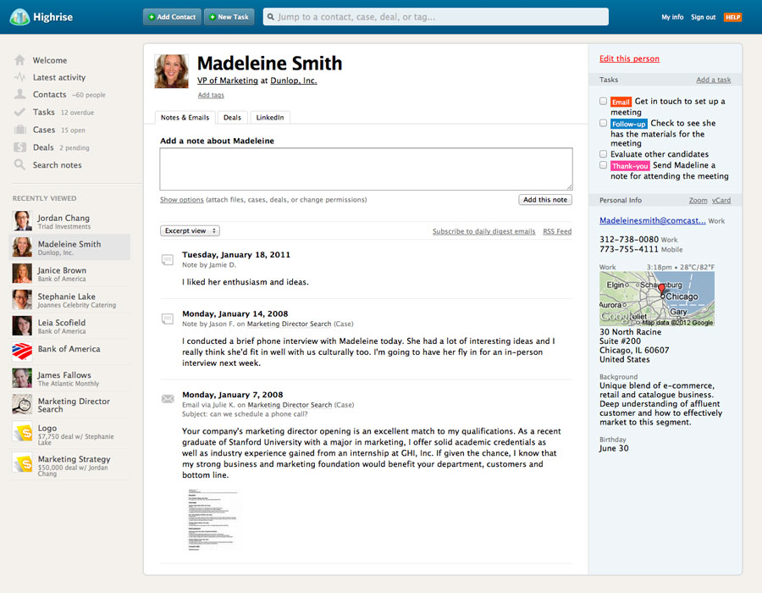

Add tasks and get things done

Tasks help you get things done. Assign tasks and deadlines to yourself or to others. Add action categories (Call, Thank You, Demo, Fax, Email) for quick scanning. Check them off when they're done. Highrise will even send reminders to your email account or mobile phone!

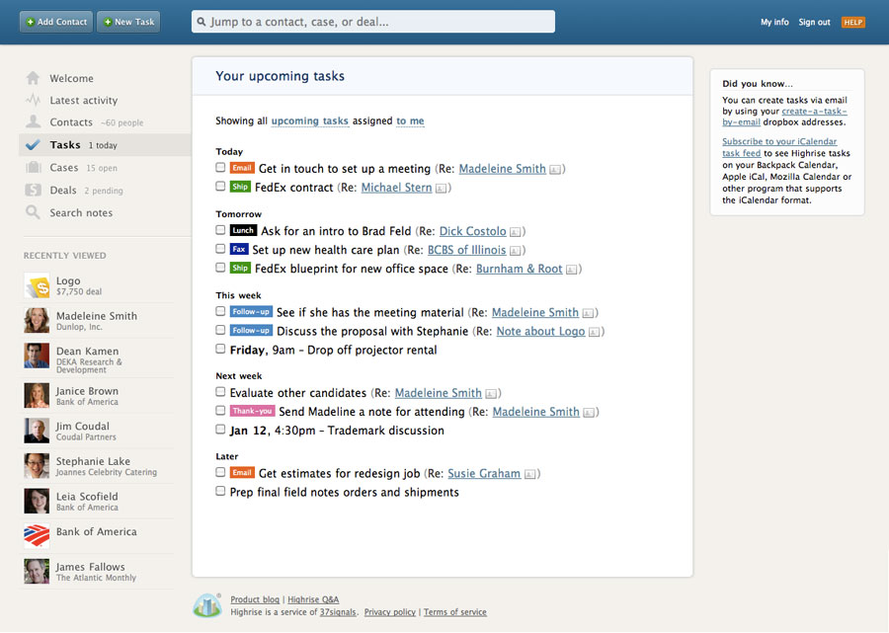

Watch an audio/video tour of Tasks

Track ‘deals’, proposals, and leads
This is for new prospects and monitors conversions which, in the bigger picture, can help you/the company to earn more!

Know which proposals/bids are pending, which you’ve won, and which you’ve lost. Enter notes about the deals, attach proposals or contracts to the deals, and keep a log of any changes. All within Highrise.

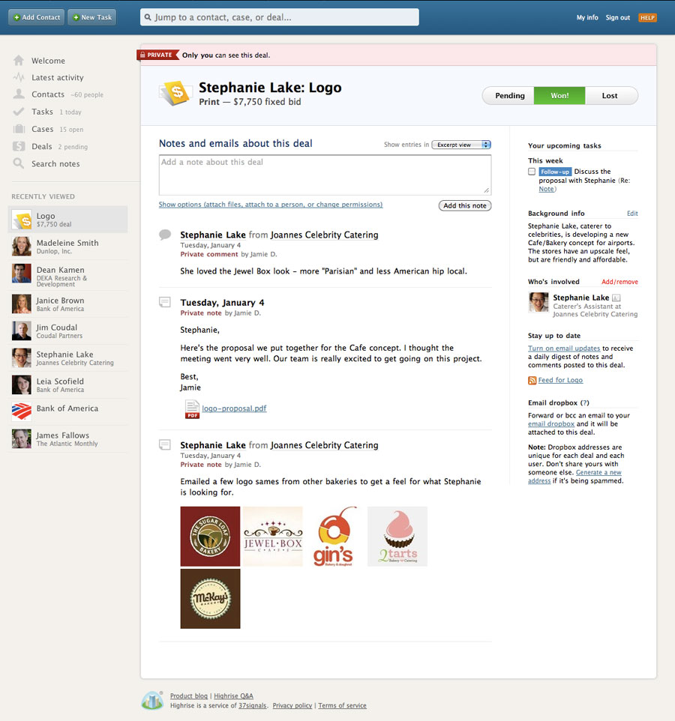

Watch an audio/video tour of Deals

Deal Categories

Categories can be applied to 'Deals' only (people or companies get ‘tags’ instead – explained elsewhere in this document). You can add a category, or choose from an existing one, when you add information to the various screens when first adding a Deal. For existing Deals you can click on the Deal, then go to Edit This Deal (top right of the screen) and then you'll see the Category drop-down selector from which you can choose a category (or add a new one). There is also a link alongside that selector to 'Edit categories' more generally by the way*. When you have finished editing your Deal’s category, click the 'Save this deal' button at the bottom of the page. The category will show up in the Deal’s list as a brightly coloured category bar.

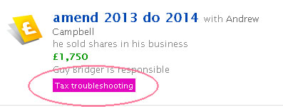

*You can also edit the Deal Categories by clicking the link on the top right of the main Deals page.

Quickly add people to Highrise
Adding a person manually takes just a few seconds. You can also upload vCards to add people even faster.

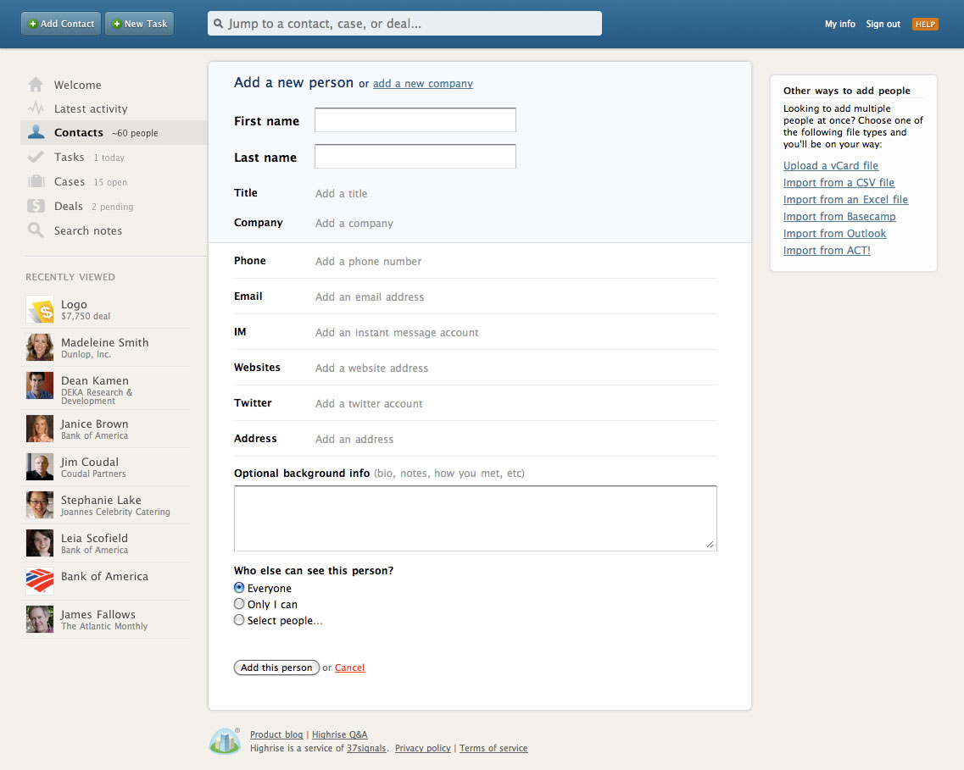

Watch a video showing how to add contacts from Outlook

Once a new prospect has been entered and recorded, don't forget to book any meeting on the dairy/calendar!

Using email to control/interact with Highrise
Highrise works together with email. You can send, BCC, or forward emails to Highrise and they'll automatically be attached to the right person’s page.

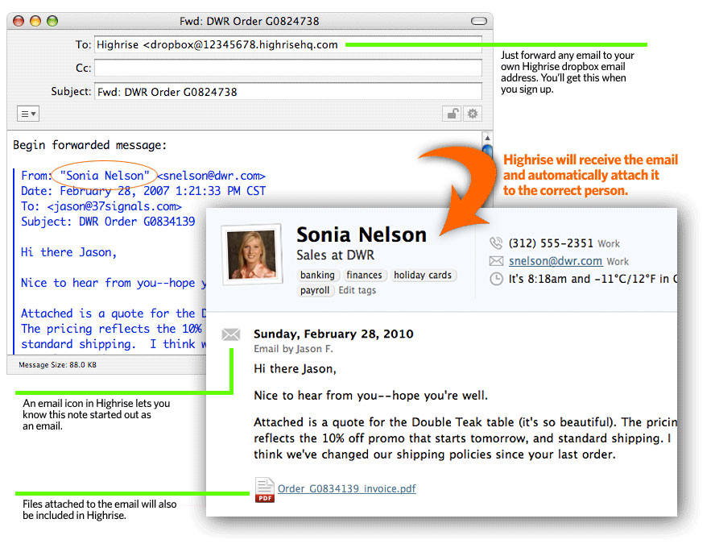

Watch a video showing how to send an email to a person page

You can also create and schedule tasks by using email:
Watch a video showing how to create tasks via email

Learn more detail about Highrise and email

Also note that ‘deals’ and ‘cases’ each have their own dropbox email addresses so you can add notes and forward emails and attachments straight to a particular deal or case, via your email application. Ask Mark FitzGibbon at Pilot (mark@pilotdesign.net 01798 815 960) about this if you can’t find the relevant dropbox email addresses.

All of your contacts in one place
All of the people who are important to your business are in Highrise. Keep track of emails, conversations, and tasks. See a list of Contacts in the ‘Contacts’ section (click link top left).

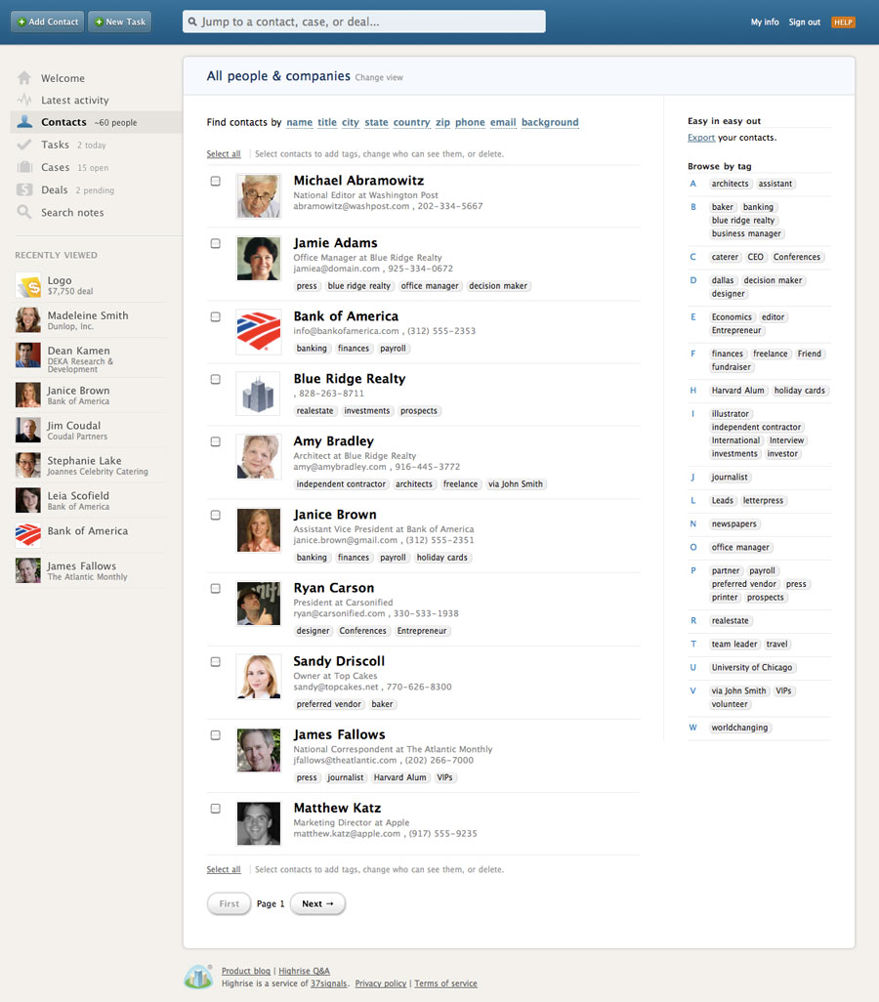

Tagging People or Companies
You can 'tag' people and/or companies with a tag of your choice. For example I have tagged myself, Julie, Daniel etc. as 'Staff'. You might find it useful to tag customers in particular ways, for example, you could tag all the tax refund customers with 'Tax Refund' and so on.

First, log into Highrise.

Next, click CONTACTS (near top left in the side navigation).

Hopefully you'll then be showing a long list of all people/companies on the page you get to. However, if you find you're only seeing one or two it will mean the system is showing the result of previous search. If that's the case you need to remove those people (click the cross next to their name in the little pale blue/grey 'lollipop’ shape near the top of the section you’re looking at). Once you've got rid of the previous 'search' results you should now see all people by default.

At the top of the page next to 'All people & Companies' (or whatever is currently the title) there is a 'Change View' link which you can click so as to see a different list (e.g. All companies, or All people, or one of many other options – choose whichever list you prefer).

TO TAG A PERSON OR COMPANY:

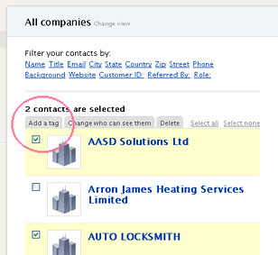
Now you see the list of, for example, all people in the system, you can tick the tick box to the left of their name. The moment you do that some additional 'tabs' come into view at the top of the list. The first is 'Add a tag' and clicking that allows you to enter a suitable tag of your choice e.g. 'Tax Return Client' or 'Bookkeeping' or whatever will be useful to you.

When you're on the Contacts page a list of existing tags appears over on the right-hand column ('Browse by tag' section). This section is also useful for searching for people with one OR MORE particular tags. To search for people with more than one tag, click the 'Multiple tags' link and take it from there. (As an exercise try searching for ‘Staff’ and ‘Left the company’ and hopefully you’ll get Anne as a result.

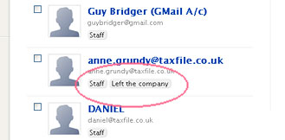
You can, as I say above, give a person or company more than one tag. For example I have tagged Anne as 'Staff' and 'Left the company' just to demonstrate this. You simply add one tag at a time - wait for it to attach the tag then do the same task again to add the second tag.

By the way, in the Search field in the centre at the top of the screen you can also search for a particular tag. For example enter Staff (capital S) and it'll bring you up a list of the staff members. However that search field does not allow you to search for people/companies with more than one tag, unlike the facility mentioned above.

Your latest activity is all in one place

Your company’s Highrise activity is summarized on the “Latest activity” screen.

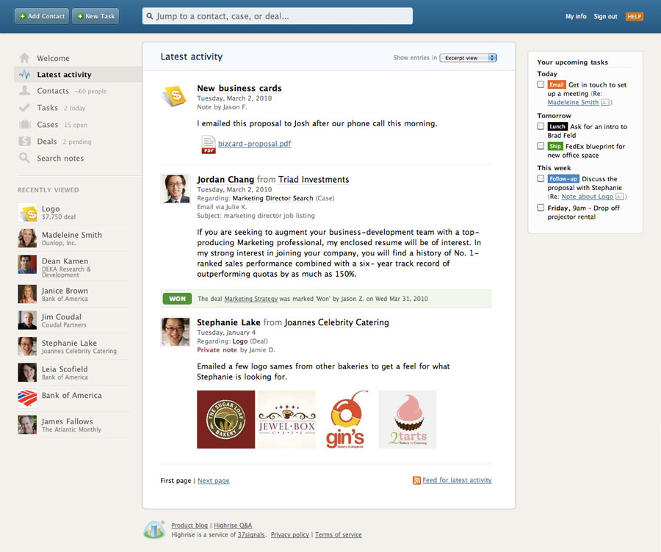

‘Cases’ keep related stuff together
Cases help you keep related notes, files, images, and people together on one screen.

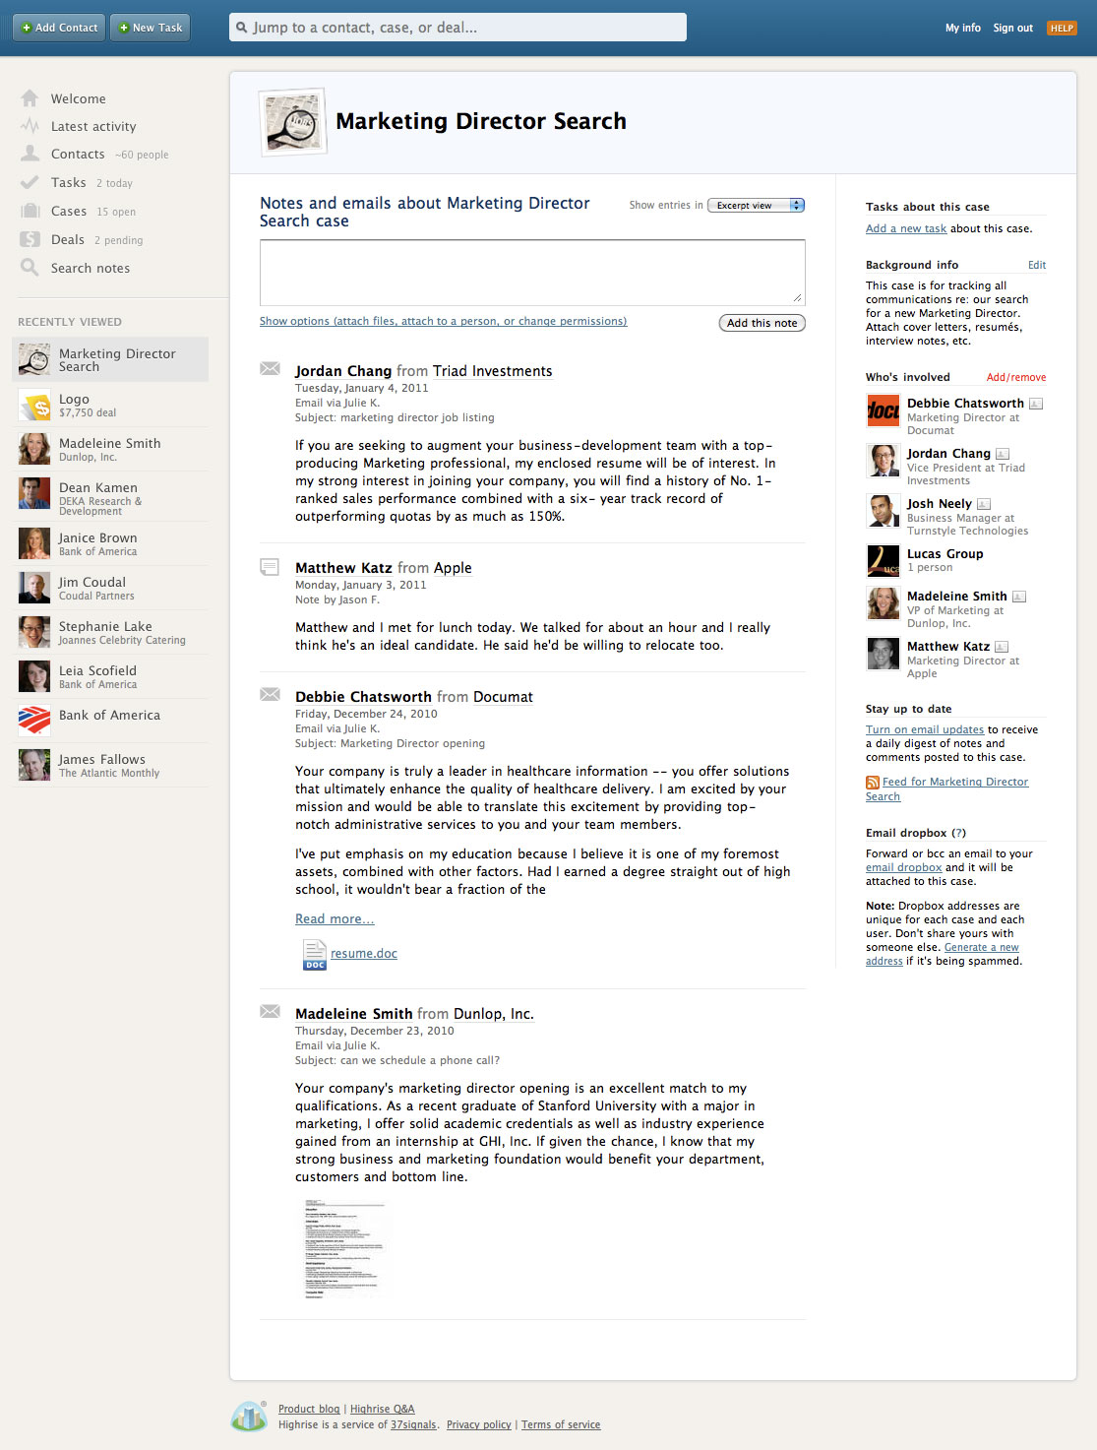

Watch an audio/video tour of Cases

Get your co-workers involved
Highrise gets better as more people in your organisation use it. The users section lets you invite people to create accounts on your system. Groups let you set batch permissions on people, notes, and cases.

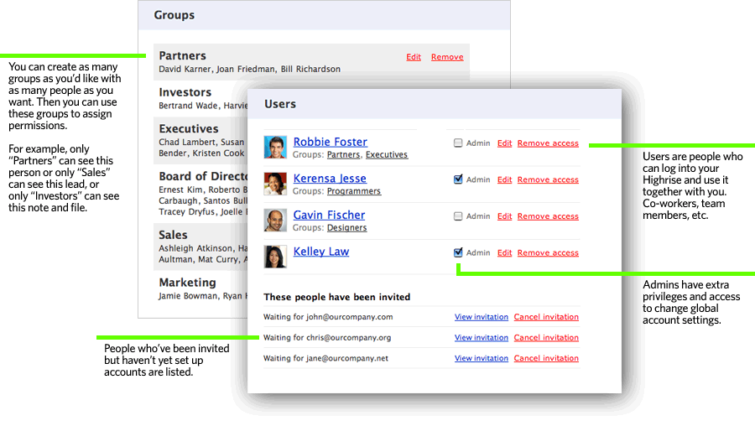

Watch an audio/video tour of Groups

Permissions

Highrise lets you specify who can see which people, companies, notes, and cases. It’s your call.

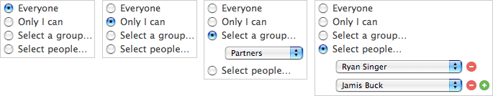

Did you know you can use or check Highrise via your iPhone?

Perhaps try downloading the App although it is *not* rated highly by users last time I checked, nor does it sound like it’s fully functioning according to a user who commented that it, allegedly, does not do 'deals' via iPhones. So worth a look, perhaps, but it might be limited. You can apparently access your Highrise contacts on an iPhone or Android phone.

The App is called "37signals Highrise" By Basecamp, LLC.
If you do want to try the iPhone version, see:
http://itunes.apple.com/us/app/37signals-highrise/id363576301?mt=8

More Help & Information including F.A.Q.s
See https://help.highrisehq.com/highrise/ and you can also always contact Mark FitzGibbon at Pilot Design to see if he knows the answer to any query you might have.
mark@pilotdesign.net | Tel: 01798 815 960 | or see lesson plan section (page 15)

BACK TO TOP

LESSON PLAN (September 2014)

Mark to hand over printed Word document (this) and show staff member the link on the taxfile.co.uk/staff.htm page for live version to download.

Note that the linked videos are from an older version of Highrise so the location of menus has changed since they made the videos (& possibly screen grabs shown in this document too), but it doesn’t really matter as it’s pretty intuitive and they all still help immensely, despite things having moved around a bit. We'll go through the new locations of admin next anyway.

Staff member: please have your Highrise login ready.

SETTINGS:
1. Log into Highrise by going to home page highrisehq.com and clicking sign in (top right).

2. Navigate to SETTINGS > MY INFO
> note the dropbox email purpose (suggestion: bookmark!).
> note the email list further down the same page;
> change to 2nd tab and check the time zone and format are correct;
> change to 3rd tab and check phone/email notifications are set up OK.
> note the export/download options on r/h/side.

3. Navigate to SETTINGS > GROUPS
> Mark to explain what these are for. Perhaps set one up if required.

4. Navigate to SETTINGS > CUSTOM FIELDS
> This is best explained by the 3 existing examples and the blurb shown on the
set-up page.
> pick a person e.g. Anne McKay and see how that custom info shows.
> note the importance of the 'Referred by' field (for marketing purposes).
> also please see and use the referrals form on the taxfile.co.uk/staff.htm page.

LATEST ACTIVITY
Navigate to Latest Activity (top left).
> At the top note that you can show All Users, or just you.
> Note the difference between Excerpt view and List view.

ADD A [PRETEND] PERSON
> Note the ADD CONTACT button top left.
> Before adding a new contact maybe use the search function (top centre) to check
they're not already there (both name AND company are worth checking). If not
already present:
> Use ADD CONTACT button top left to add a person.
> Fill in fields and point out the 3 bespoke fields (came via Settings > Custom Fields)
> Remember to include 'Referred By' field for marketing purposes.
> Note the 'who can see' radio buttons etc.
> BEFORE SAVING note that you can add a company too, particularly useful if
more than one client works at the same company.
And save at the bottom.

ADDING A NOTE
> Click the person if not already selected and see how to easily add a note to that
person's file.
> Under the 'Add a note about Joe Bloggs' input field click 'Show Options' so you can
try attaching a document (e.g. scanned lead sheet) to the person's file.
> Go through the other fields in this form (e.g. emailing other staff or yourself for
this note).
> Go to 'Latest Activity' (top left) and now you'll see that the new person or company is
in the Latest Activity feed.
> Note that each entry is clickable.

TASKS
> In side navigation (‘nav’) 3 down, click on TASKS
> See how many tasks you have;
> If none, set one up for yourself (or someone else) by using the '+ NEW TASK' button
at the top.
> When setting up note the various field options including categories and 'edit' function
alongside that field. When ready click the ADD THIS TASK button.
> Show how it now appears under TASKS in side nav.
> If it's not a task for you then use the filters to find tasks for a different person
(assuming viewer is an 'admin').
> If it's a task for yourself then also navigate to 'Latest Activity' to show how the task
nag screen appears top right of that summary page.
> Note that the task is also emailed to the person who has been allocated the task.
> And nearer the deadline the system will remind the person responsible again.
> To tell the system the task has been fulfilled, tick the box on that task (on the above
page).
> Also note the 'change' option (to change the wording of the task' when you
hover over the task (wherever it might show). Also a delete option is there.
> Now go to Joe Bloggs and see (top right) that there is an option to 'Add a task about
Joe'. Reason is that a task allocated this way will attach itself to Joe's own page so it'll show in the activity for Joe Bloggs (or a company ... or a case ... or a deal [see below]). For example you could set yourself a task to 'make follow-up call if you haven't heard from Joe by 29 September'.
> Back on the TASKS pane, view the DID YOU KNOW box top right, firstly about
creating a task by email (see next bullet) and secondly about subscribing to your
iCal calendar task feed. NB Mark at Pilot hasn't tried this yet but it might be worth
looking at, for calendars which can import more than one iCal feed.

> Now also see Word Doc (page 8) and use the links to watch the relevant video(s)
about how to use email to set tasks.

Mark to explain why tasks are so important. For example if you ring a brand new prospect (e.g. one who enquired via the website) and they are not in and you leave a message, it would be easy to forget to do anything about the prospect should you later forget all about it (assuming they never returned your call). So instead, when you leave the prospect a message you could/should also set yourself a task (attached to that person or that person's case in Highrise) to try the prospect again in, say, 2 or 3 days (tasks can have deadlines which you choose). And if they're still out then do it all again. So long as MY INFO is set up correctly, the system will email you (and possibly SMS you but rely more in email as that is tried and tested) ... and of course show, you when logged into the Highrise screen, that you need to fulfill that task (via email it'll nag you at the time it's due, and beyond).

Mark to explain later why keeping on top of new prospects could be mutually beneficial to both the company AND to the particular staff member involved (see DEALS section later on).

CASES
Mark to explain why cases might be more useful than *only* people. For example for Joe Bloggs you could open a case for his 2014 tax return. When done you can close the case. Next year you can open a 2015 tax return case for Joe and notes/attachments/emails for that case will then be separate from the older ones.

> Go to Joe Bloggs and open it up;
> See how you can use the 'Show options' under the add note field in order to open a
new case (or an old one) for Joe.
> Note the need for meaningful headings (and maybe job numbers).
> Maybe make a dummy case for Joe Bloggs and save it.
> Go back into the case (various ways to do that - via Cases top left of on the 'cases
tab' within Joe Bloggs's page).
> Once the case is open note the various sections of that case page including
'who's involved' over on the right hand side.
> Click 'Edit this case' (in red top right);
> At the next screen note again who can see this case and also ...
> note 'Delete this case' (top right in red) or 'This case is ... open ... or closed'
radio buttons in centre area, then save.
> In side navigation at the top click on CASES;
> Note that only open cases are in view but click on 'Show Closed Cases' to see closed
ones.
> Click on a closed case.
> Click 'edit this case' to re-open it (save with radio button set to 'open' if you want to
re-open a closed case).

SEARCH NOTES
Briefly try out this feature (top left in side nav, 6th item in list).
Compare to top search function which is not searching ‘note content’ but cases, people, etc.

DEALS
Now the fun begins!

> Go to DEALS (top left on side nav).
> Take a look at existing deals on that screen ... but ...
> Click ADD A NEW DEAL button at the top.
> Fill in the form. Note that 'who's this deal with' will do a live search for a person you
are typing in e.g. try typing in Joe Bloggs and it'll find him so the system will link the
deal to the person. If it's a new name it'll give you the option to choose whether to
add that person as a 'new name' or as a 'new company' (you need to choose one or
the other).
> Create a meaningful name for the deal (e.g. Bookkeeping for Joe Bloggs y/e April
2014)
> Describe it in greater detail below if that will help in the future
> Give it a target value in £
> ... etc. (fill in the rest of the form) and click the ADD THIS DEAL button.

> If/when the prospect and job have converted to a 'done' job/deal, then you can go to the deal (select from the list under DEALS) then simply click the large 'WON' button and agree to the change.
> Back on the main DEALS page you can then see totals for 'won' jobs, lost jobs and pending jobs etc.

WHY ARE DEALS IMPORTANT?
Mark to explain Guy's incentive idea (although still not fully nailed down at time of writing).

WHY ARE TASKS IMPORTANT?

Note that "tasks" are very important in respect of the above. For example if you ring a brand new prospect (e.g. one who enquired via the website) and they are not in and you leave a message, it would be easy to forget to do anything about the prospect should you then forget all about it (assuming they never returned your call). So instead, when you leave the prospect a message you could/should also set yourself a task (attached to that person or that person's case in Highrise) to try the prospect again in, say, 2 or 3 days (tasks can have deadlines you choose). And if they're still out then do it again. So long as MY INFO is set up correctly, the system will email you (and/or SMS you ... and of course show you when logged into the Highrise screen) that you need to fulfill that task (via email/SMS it'll nag you at the time it's due).

Mark to explain why keeping on top of new prospects could be mutually beneficial to both the company AND to the particular staff member involved (see DEALS sections above, p5 and 17).

CATEGORIES & TAGS
See relevant sections above for instructions (for tags see page 10, for deal categories see page 6) – Mark will explain these on site during the training sessions.

More Help & Information including F.A.Q.s
See https://help.highrisehq.com/highrise/ and you can also always contact Mark FitzGibbon at Pilot Design to see if he knows the answer to any query you might have.
mark@pilotdesign.net | Tel: 01798 815 960 | or see the lesson plan section

Thank you for your time!
Best regards,



BACK TO TOP

